**NEPATHYA COLLEGE**

**(Tribhuvan University)**

**Tilottama-2 jankinagar, Rupandehi**



**Lab Report of "Mr. Abhishek Regmi "- "BCA"-"**

**“Humanity and Social Science”**

**Tribhuvan University**

**Kirtipur Nepal**

**Submitted By**

**Name: Mr.Abhishek Regmi**

**Roll No: 1**

**Submitted to**

**Nepathya College**

**Department of Computer Science and Information Technology**

**Tilottama-2, Nepal**

**Curriculum Vitae**

**Name : Abhishek Regmi**

**Address : Singaha – 4 flat No: 12**

**Devdaha Rupandehi, Nepal**

**Mob NO: 9867835306**

**: 9821974500**

**E-mail :** [**Avisekregmi1212@gmail.com**](mailto:Avisekregmi1212@gmail.com)

|  |
| --- |
| **C A R E E R O B J E C T I V E** |

* Looking for long term association with people orientated organization where individual talent skills and hard work acknowledge work culture providing with intellectually stimulating environment and rewarding career.

|  |
| --- |
| **E D U C A T I O N A L Q U A L I F I C A T I O N** |

* 10th pass from Green plant school
* 12th pass from ISMT college
* PDICA certificate with ISO certified

|  |
| --- |
| **E X P E R I E N C E** |

* 2 years of teaching experience computer in karthford institution
* Worked as a junior web developer in xyz company for 2 years.
* Presently working on BCD Company as a cyber security.

|  |  |
| --- | --- |
| **Please type your answers. Use an additional pieces of paper if necessary .** | |
|  | **Last Name : First Name:** |
| **2.** | **Mailing address :**  **Street :**  **City : State : Zip :** |
| **3.** | **Daytime Telephone Number : ( )**  **Email Address :** |
| **4.** | **Date of birth : Month : Day: Year:** |
| **5.** | **Cumulative Grade point Average (GPA)___________(On a 4.0 scale)** |
| **6.** | **Name and Location of High School:** |
| **7.** | **A. List of any academic honors, awards, and membership activities while in high school.**  **B. List of your hobbies, outside interest, extracurricular activities and school related volunteer activities.**  **C. List your non-school sponsored volunteer activities in the community.** |
| **8.** | **A. If you have decided on the college you will attend, Please list the school name.**  **B. If you not list your top three (3) college choices.** |

|  |  |  |
| --- | --- | --- |
|  |  |  |
| Jan 2020 | Tuesday | Wednesday |
| 1  New year | 16 |
| Wednesday | Thursday |
| 2 | 17 |
| Thursday | Friday |
| 3 | 18 |
| Friday | Saturday |
| 4 | 19 |
| Saturday | Sunday |
| 5 | 20 |
| Sunday | Monday |
| 6 | 21 |
| Monday | Tuesday |
| 7 | 22 |
| Tuesday | Wednesday |
| 8 | 23 |
| Wednesday | Thursday |
| 9 | 24 |
| Thursday | Friday |
| 10 | 25  Sonam losar |
| Friday | Saturday |
| 11 | 26 |
| Saturday | Sunday |
| 12 | 27 |
| Sunday | Monday |
| 13 | 28 |
| Monday | Tuesday |
| 14 | 29 |
| Tuesday | Wednesday |
| 15 | 30 |
|  | Thursday |
|  | 31 |

|  |  |  |
| --- | --- | --- |
|  |  |  |
| Feb 2020 | Tuesday | Wednesday |
| 1 | 16 |
| Wednesday | Thursday |
| 2 | 17 |
| Thursday | Friday |
| 3 | 18 |
| Friday | Saturday |
| 4 | 19 parjatantra divas |
| Saturday | Sunday |
| 5 | 20 |
| Sunday | Monday |
| 6 | 21 shivaratri |
| Monday | Tuesday |
| 7 | 22 |
| Tuesday | Wednesday |
| 8 | 23 |
| Wednesday | Thursday |
| 9 sawstani | 24 galpo losar |
| Thursday | Friday |
| 10 | 25 |
| Friday | Saturday |
| 11 | 26 |
| Saturday | Sunday |
| 12 | 27 |
| Sunday | Monday |
| 13 | 28 |
| Monday | Tuesday |
| 14 | 29 |
| Tuesday |  |
| 15 |  |
|  |  |

**‘News Today**

www.newsT.com

Thursday,

23,Feb,2020



**ANONYMOUS WAR WITH ISIS COULD LEAD TO SPREAD OF INTERNET CENSORSHIP, GROUP WARNS**

Anonymous began its campaign against Isis in the wake of the Charlie Hebdo shootings earlier this year. It stepped it up again after the Paris attacks, using tactics like hacking suspected members of the group and working to shut down social media accounts and websites.



**United States of America (U.S.A) governmental websites has been hacked by the Iranian hackers.**

Officials were still investigating the attack, which was consistent with the work of low-level Iranian nationalist hackers looking for easy American targets, experts said.

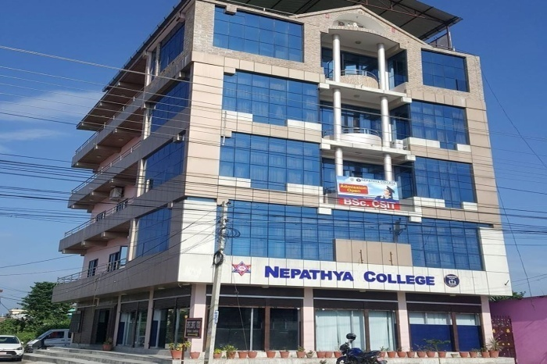

**Nepathya college of Butwal organizing**

**Hackathon.**

It is said that Peoples not only from whole

Nepal but also from peoples are coming to

Participate in program. Program is going to

Be huge so the program will take part in the

Déjà VU Hotel of Khaireni. People have

Announced the prize for 1st 2nd and 3rd

As from source, 1st will get the prize of RS.50k.

And 2nd will get the 30k. And 3rd will get the RS.15k.

Abhishek Regmi

Devdaha-4-khaireni

[Avisekregmi1212@gmail.com](mailto:Avisekregmi1212@gmail.com)

2020/2/1

ABC company

To The Manager

Subject: An Application for the post of Java Programmer

Greetings!

I found on Ad on Newspaper you and your company is seeking for a java developer. I have graduated Information Technology from Nepathya College of Butwal.

Recently I have worked as junior java developer in xyz company of Khaireni. I have 2 years of experience on java language.

As requested, I have attached my Resume for you to review. My contact details are also provided their. Please don’t feel hesitate to call me.

Thank you for this opportunity, and I look forward to hearing from you.

Sincerely Yours

Abhishek Regmi



Mr Razon Qumal

From Butwal

**21st Feb 2020**

6.00 Evening

B25 hotel ,Khaireni

Devdaha Khaireni

My email and phone number

9876521345 abhishekregmi@gmail.c



Mr Suntosh Tiwary

From shitalnagar

**21st Feb 2020**

6.00 Evening

B25 hotel ,Khaireni

Devdaha Khairni

My email and phone number

9876521345 abhishekregmi@gmail.com



Mr Prajwal Tiwary

From Pokhara

**21st Feb 2020**

6.00 Evening

B25 hotel ,Khaireni

Devdaha Khairni

My email and phone number

9876521345 abhishekregmi@gmail.com



Mr Touhid Mahumud

From Kathmandu

**21st Feb 2020**

6.00 Evening

B25 hotel ,Khaireni

Devdaha Khairni

My email and phone number

9876521345 abhishekregmi@gmail.com



Mr Ranjeet Gaha

From Syanja

**21st Feb 2020**

6.00 Evening

B25 hotel ,Khaireni

Devdaha Khairni

My email and phone number

9876521345 abhishekregmi@gmail.com